Instructor: Mauricio Castro | Office: Online
Email: mfcastro@purdue.edu | Office Hours: Via Skype, by request

History 152
United States History since 1877
Second Eight Week Course, Spring 2017

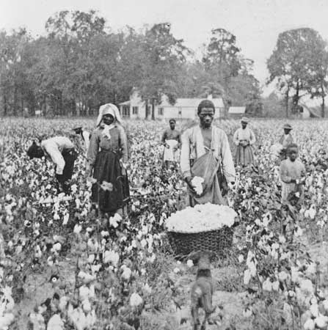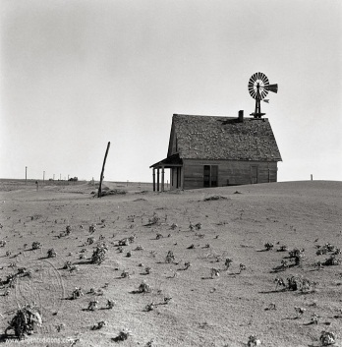

Course Introduction:
Welcome to History 152! This course is an introduction to modern American history. It covers the social, economic, and political developments within the United States as well as its diplomatic history in the period of its emergence as a leading world power. This course is designed to provide general information about U.S. history between 1877 to the present. During the latter half of the semester we will examine the vast changes, primarily in American society, that created the America we live in today. We will also discuss aspects of American culture that have remained the same through the last 100 years. Obviously, we cannot cover everything but in an attempt to do justice to all the fascinating events and people that helped develop modern America we will move quickly and try to hit all the high points. Overall, and perhaps most importantly, we will emphasize that history is not simply an array of names and dates confined to the past. History is what makes us who we are, and what makes our society what it is today.

Course Objectives:
By the end of this semester you are expected to have a better understanding of the history of the United States from 1877 to the present. You will be exposed to a variety of primary sources from different eras, and you are expected to learn to use and think about them critically. In the exams and written assignments you are expected to identify, think, and write clearly about important aspects of American history covered in this course.

Requirements of Online Learning:
Online learning requires self-discipline and independence. You will need regular access to a computer as well as a back-up computer (e.g. computer labs, libraries, etc.) in the event that your personal computer breaks down. Your computer(s) must be Flash enabled and it is the students’ responsibility to secure access to a reliable internet connection. Computer crashes, lack of correct programs, and internet outages will not be accepted as valid excuses for missed assignments. If you experience technical issues, you should contact ITAP for assistance.

Course Overview and Requirements:
This is an eight-week, accelerated course. As such, we will cover material very quickly. The course is broken down into eight units. The units will roughly, but not uniformly, coincide with the calendar weeks of the condensed semester. There will be quizzes due at the end of the second and sixth units. You will have exams after the fourth and eight units. You must also contribute to discussion boards at least once per unit, including the regular semester’s spring break and dead week.
It is your responsibility to keep up with the readings and assignments. For the duration of the class, you can expect to read the equivalent of two to three book chapters a week and accompanying primary source documents, sometimes more. You will also be responsible for viewing and responding to PowerPoints and other materials placed on Blackboard Learn. You are responsible for taking quizzes and exams within the specified time frames and due dates. Late work will not be accepted and there will be no make-up exams. You must contribute to the online learning experience of the class by participating in the group discussion boards. Your grade is dependent upon both your participation in the class and your timely completion of all assignments.

Assigned Text and Readings
- Give Me Liberty!: An American History, Fourth Seagull Edition, Volume 2 – Eric Foner – ISBN – 0393920313
  - This will be your textbook for the duration of the course. As such, the book will be your main source of information for your responses to quizzes and exams.
- Voices of Freedom: A Documentary History, Fourth Edition, Volume 2 – Eric Foner – ISBN – 0393922928
  - This is a reader of primary sources meant to enhance your reading of the textbook. Primary source materials are incredibly important in the study of history, they provide the first-hand accounts of what transpired and the multiple perspectives on these events from the people who experienced them. Primary sources are crucial for historians trying to understand the past. In your case, you will be expected to refer to these sources in the short essays in your exams and to answer questions about them in your quizzes.

Unit Addendums:
In each of the Unit Content areas—along with reading assignments, quizzes, and links to the discussion forums—you will also see unit addendums. These are brief PowerPoint slideshow presentations meant to accompany your reading in Give Me Liberty! You can think of them as mini-lectures. They are my way of highlighting some of the things the textbook covers or giving more emphasis to certain subjects. They are meant to stimulate discussion and draw attention to some of the broader themes of this course. There will a corresponding unit addendum for each of the week’s units. These slideshows will generally be about 60 minutes, sometimes longer. I highly suggest you take notes as you watch and listen to these slideshows, much as you would during an in-class lecture. I also suggest that you watch these slideshows after you read the textbook chapters. On exams, you will be responsible for both the material covered in the textbook as well as the unit addendums.

Communication:
All communication with me will take place over Blackboard Learn and via email. If you need a more in-depth meeting than we can cover in email, you can contact me to arrange a Skype meeting. Besides that, all questions relating to basic course information should be addressed to the General Course Questions discussion forum located in the discussions area. This discussion board for is for any general questions about how the class operates. Here you ask questions about the syllabus, assignments, readings, exams, and quizzes. You should also review this board before asking questions or sending emails about general questions, as the question may have already been asked by another student. This is a place to troubleshoot problems before it’s too late to make corrections. You should use it to your advantage.

Exams:
There will be two exams. The first will take place after the 4th unit of class and will evaluate you on the readings and other materials covered in Part I (see Course Schedule). The second will take place during the final week of class and evaluate you on the readings and materials covered in Part II. The final exam will not be cumulative. Each exam will be worth 100 points toward your final grade.
The exams will be based on both multiple choice and short essays. Each exam will consist of five multiple choice questions and six short essay questions out of which you must pick and answer two. You will receive a review sheet with possible essay questions about a week before the exam is due.

Quizzes:
There will be two quizzes over the course of the semester. See the course schedule for due dates and times. The quizzes will cover the material from your textbook and your document reader and will ask you to respond to multiple choice questions and a short essay. You will not be able to make-up a quiz under any circumstances. A quiz will be due at the end of the second and sixth units. The total of two quizzes will be worth 100 points.

Class Participation:
Effective online learning requires the active participation of everyone in the class. Since we do not have a traditional classroom, we try to replicate that experience through interactive discussion boards. The use of these discussion boards will be to facilitate discussions and ideas that go beyond what can be learned from the readings. In these forums, you are encouraged to question, challenge, and debate the meaning and significance of the material covered in the class.
Class participation will take place in the course discussion boards. You must contribute at least one entry per unit, but should plan to contribute more to receive full credit. I will place prompts and questions regarding the week’s materials in the discussion boards near the beginning of each unit. You should respond to these prompts, but you are also encouraged to make your own observations about the readings and primary sources and engage your classmates’ discussion posts. In all cases, your class participation grade is dependent on your engagement both with the material and your classmates. The grade will consider both the quantity and quality of your discussion posts, which are due by the end of the night on Tuesdays. Class participation is worth 80 points toward your final grade. Please note: You will not receive full credit for your participation if you only contribute the bare minimum of discussion posts.
Additionally: In all discussions, you are required to be respectful to your classmates, to me, and to the material we’re covering. Disagreement and debate are encouraged, but rudeness and hostility will not be tolerated. I will report any and all disruptive, harassing, or disrespectful behavior to the Dean of Students.

History in Your Own Lives Assignment:
As we go through the class units, you will be able to identify several recurring themes in modern American history. In order to test your ability to identify these themes and to apply these skills to your lives, I will be asking you to identify three significant events or trends that occurred in the past 15 years and how they relate to the class’s themes. I will expect you to really do some thinking on this and to go beyond the most obvious answers.

Class Point Breakdown:
Your final grade will be based on a 400 point scale. The breakdown of all of the grades is as follows:

Scale:
Test 1 – 100 points 400 – 360 points = A range grade
Test 2 – 100 points 359 – 320 points = B range grade
Quizzes – 100 points 319 – 280 points = C range grade
Class Forum Participation – 80 pts. 279 – 240 points = D range grade
History in Your Own Lives – 20 points 239 – 0 points = F

Academic Dishonesty and Plagiarism:
Purdue’s Definition of Academic Dishonesty:
Purdue prohibits “dishonesty in connection with any University activity. Cheating, plagiarism, or knowingly furnishing false information to the University are examples of dishonesty.” [Part 5, Section III-B-2-a, University Regulations] Furthermore, the University Senate has stipulated that “the commitment of acts of cheating, lying, and deceit in any of their diverse forms (such as the use of substitutes for taking examinations, the use of illegal cribs, plagiarism, and copying during examinations) is dishonest and must not be tolerated. Moreover, knowingly to aid and abet, directly or indirectly, other parties in committing dishonest acts is in itself dishonest.” [University Senate Document 72-18, December 15, 1972]
Please make sure you are familiar with the university’s academic integrity policies:
https://www.purdue.edu/odos/welcome/academic-integrity/

Personal Policy Regarding Plagiarism:
Academic dishonesty is nothing short of an insult to the hard work put forth by both instructors and students in the university’s learning environment. I have a zero tolerance policy towards academic dishonesty in my class. Any instance of plagiarism or any other sort of academic dishonesty will be immediately reported to the Dean of Students office and the offending student will immediately receive a failing grade for the course. For clarity’s sake, this includes any undocumented replication of another’s work, whether that work is taken from the textbook, the reader, another student, the web, or any other source. Materials for this course should come from the assigned readings and materials, not the web. I did not assign Wikipedia or any other website for this course. I will consider all answers and responses taken from unauthorized sources as cheating. In a class of this nature—where there is limited supervision and extracurricular content is widely available—it is very easy and tempting to commit plagiarism. But be warned: it is also very easy to catch instances of academic dishonesty. If you are unsure about whether something will be regarded as plagiarism, ask before you submit your material.

Changes:
In the event of a major campus emergency, the above requirements, deadlines and grading policies are subject to changes that may be required by a revised semester calendar. Any such changes in this course will be posted as soon as they can be made available or obtained by contacting the instructor. In addition, I reserve the right to change assignments, add assignments, subtract assignments, and offer extra credit.

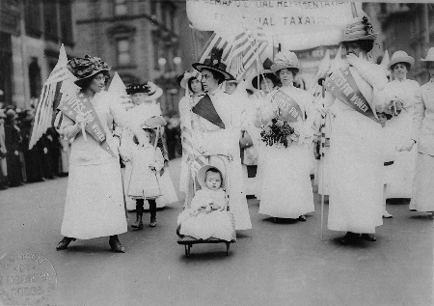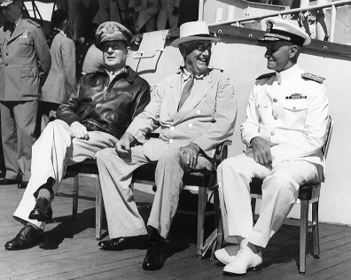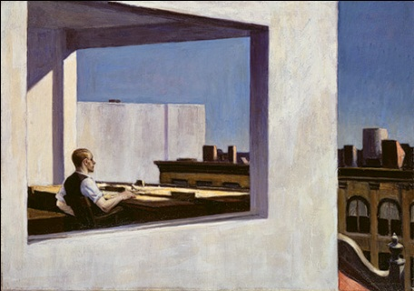

Course Schedule:
The following course schedule is broken into two parts, each with four units. The Exams will take place after each part. Any reference to the “Textbook” refers to Give Me Liberty! Reference to “Reader” refer to Voices of Freedom.

Part I

Unit # | Dates and Assignments | Readings
Unit 1:  Reconstruction and the Gilded Age | Unit 1 Begins March 6, 12:00 a.m.  Unit 1 Ends March 12, 11:59 p.m. | Textbook:  Chapters 15 and 16  Reader:  Chapters 15 and 16
Unit 2:  Imperialism, Capitalism, and Progressivism | Unit 2 Begins March 13, 12:00 a.m.  Unit 2 Ends March 19, 11:59 p.m.  Quiz 1  Available March 16, 12:00 a.m.  Due by March 19, 11:59 p.m. | Textbook:  Chapters 17 and 18  Reader:  Chapters 17 and 18
Unit 3:  The War to End All Wars and the World That Followed | Unit 3 Begins March 20, 12:00 a.m.  Unit 3 Ends March 26, 11:59 p.m. | Textbook:  Chapters 19 and 20  Reader:  Chapters 19 and 20
Unit 4:  The Great Depression and the New Deal | Unit 4 Begins March 27, 12:00 a.m.  Unit 4 Ends April 2, 11:59 p.m.  Exam 1  Available March 30, 12:00 a.m.  Due by April 2, 11:59 p.m. | Textbook:  Chapter 21  Reader:  Chapter 21

Part II

Unit # | Dates and Assignments | Readings
Unit 5:  The World in Flames and the Start of the Cold War | Unit 5 Begins April 3, 12:00 a.m.  Unit 5 Ends April 9, 11:59 p.m. | Textbook:  Chapters 22 and 23  Reader:  Chapters 22 and 23
Unit 6:  The Cold War at Home | Unit 6 Begins April 10, 12:00 a.m.  Unit 6 Ends April 16, 11:59 p.m.  Quiz 2  Available April 13, 12:00 a.m.  Due by April 16, 11:59 p.m. | Textbook:  Chapter 24  Reader:  Chapter 24
Unit 7:  The Long 1960s and the Rise of Conservatism | Unit 7 Begins April 17, 12:00 a.m.  Unit 7 Ends April 23, 11:59 p.m. | Textbook:  Chapters 25 and 26  Reader:  Chapters 25 and 26
Unit 8:  The End of the Cold War and the Spread of Globalization | Unit 8 Begins April 24, 12:00 a.m.  Unit 4 Ends April 30, 11:59 p.m.  History In Your Own Lives Assignment  Due by April 26, 11:59 p.m.  Exam 2  Available April 27, 12:00 a.m.  Due by May 1, 11:59 p.m. | Textbook:  Chapter 27  Reader:  Chapter 27

